Emerson Commercial &
Residential Solutions
Emerson Digital Cold Chain
7121 Fairway Drive Suite 400
Palm Beach Gardens, FL 33418 USA

Subject: Regulatory Approvals

Dear Valued Customers,
Emerson Cargo Solutions has received the formal approval certificates for Model: GO Real-Time 4G/5G-LT Tracker (GO Tracker 1.7) from the following agencies:
Model: GO Real-Time 4G/5G-LT Tracker (GO Tracker 1.7)
Products Applicable:
- GO Real-Time 4G/5G -LT
- GO Real-Time XL 4G/5G-LT
- GO Real-Time Reusable 4G/5G-LT
U.S.    FCC ID: AMH101014 | Dominican Republic  
Canada  IC: 10124A-101014 | Australia  
Europe    Z.I. Via dell’Industria, 27 32016 Alpago (BL) Italy | Brazil    ANATEL:00134909
RTCA/DO-160G (Section 21) Category H | Thailand  NBTC: B69009-22
Honduras  CONATEL: 20211027HM77 | Israel  MOC:11-12320
Mexico  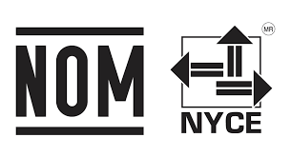 | Philippines  ESD-CPE-2103718

