

**Tornado in a Jar**

**3-5**

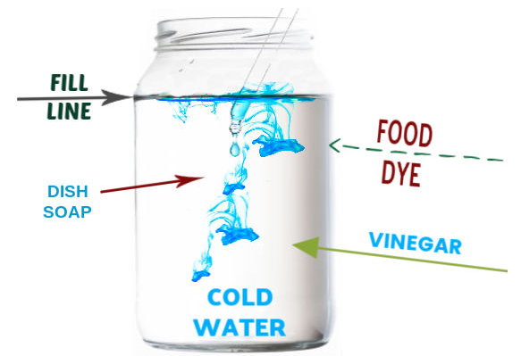**Estimated Time**: 20 minutes

# **Materials (per student):**

* Mason jar OR clear plastic container with lid
* 3 cups of water
* 1 tablespoon dish soap
* 1 teaspoon vinegar
* Glitter

# **Instructions:**

1. Fill the jar with water leaving 1-2 inches of space at the top
2. Add 1-3 drops of food coloring and approximately 1 teaspoon of glitter (optional)
3. Add 1 tablespoon of dish soap
4. Add 1 teaspoon of white vinegar, close the jar and mix gently
5. With a firm grip on the jar swirl several times in a circular motion then stop and watch your tornado!

# **Possible Variations:**

* Several trials can be done as time allows. How does speeding up or slowing down the swirl effect the size/shape of the tornado?
* Add additional color to the jar for a different look

# **Science Behind the Project:**

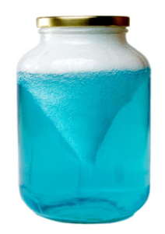As you twist the jar the water inside is pulled due to gravity and friction. The fluid toward the inside of the jar takes longer to be pulled, but eventually both the glass jar and the fluid are spinning as you rotate the bottle. When you stop rotating the jar the fluid inside keeps spinning, creating a vortex just like a tornado.