

**LED Flashlights**

# **Objective:**

**6-8**

Students learn how to make a DIY LED flashlight by using very little matierals.

# **Instructions:**

1. Choose your LED light color
2. Test your battery and LED light. Slide your coins battery between the prongs of the LED light. If everything is working, place your LED on the lip of the curved end of your jumbo craft stick.
3. Using your copper tape, guide one strip of tape from the top (covering the LED prongs) down to the cut end of the stick. Repeat on the other side.
4. Add the binder clip to the bottom of the stick with the prongs flipped up. Use transparent tape to hold the battery in place. Only cover the top of the battery with the tape. The metal prongs of your clips should touch the battery.
5. 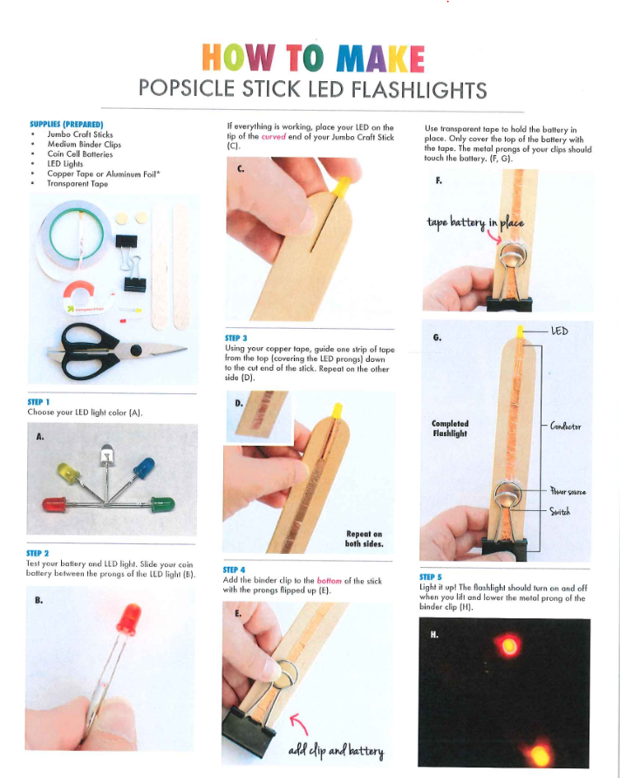Light it up! The flashlight should turn on and off when you lift and lower the metal prong of the binder clip.

# 

|  |
| --- |
| **Materials** |
| Jumbo Craft Sticks |
| Medium Binder Clips |
| Coin Cell Batteries |
| LED Lights |
| Copper Tape or Aluminum Foil |
| Transparent Tape |

# **Construction Materials:**

