

**Air Cannon**

**3-5**

**Estimated Time**: 30 minutes

# **Materials (per student):**

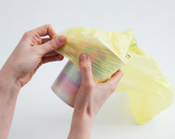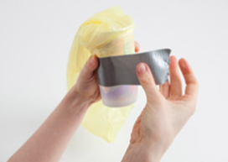

* Paper cup
* Plastic bag
* Duct tape
* Scissors
* Craft pom-poms

# **Instructions:**

1. Using the scissors poke a hole about half the size of your pom-poms in the bottom of the paper cup. Smooth the edges of the hole using your finger
2. Cover the open part of the cup using the plastic bag
3. Carefully tape the bag to the cup as shown so that it’s airtight
4. Fill the Air Cannon with air by blowing into the hole at the bottom of the cup to inflate the bag. The more air that you can keep in the cannon, the better it will work
5. Load the pom-pom into the hole in the bottom of the cup. Ensure that it fits snugly in the hole like a plug (adjust the size of the hole or size of the pom-pom as needed).
6. Fire away! Point the pom-pom in the direction that you want it to fire then squeeze the bag.

# **Possible Variations:**

If time allows this can be turned into a contest to see who can get their cannon to fire the farthest. If the bag breaks/tears it can be repaired or replaced.

# **Science Behind the Project:**

Because the pom-pom sits tightly in the hole, no air can get past. The pom-pom is a plug, sealing the air chamber. But it is a weak plug that can pop out. When you squeeze, you increase the air pressure inside the Air Cannon. At some point the air pressure overpowers the pom-pom’s seal. Now, the air rushes out, carrying the pom-pom with it.