

**Kite Crafting**

**K-2**

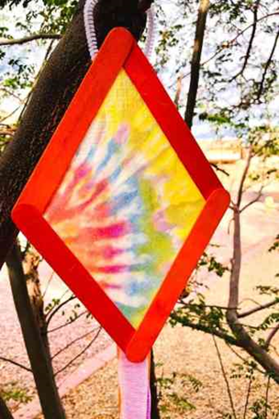

# **Materials:**

* Craft Sticks
* Streamers (Ribbon)
* Pipe Cleaners
* Scissors
* Hot Glue Gun (Adult Only)
* Tissue Paper

# **Instructions:**

1. Glue the craft sticks in the shape of the kite.
2. Using the frame, cut measure the kite material, cut to size and glue to frame.
3. Attach ribbon to one end of the frame from the back of the kite.
4. Attach the pipe cleaner to the opposite end of the kite (from the ribbon) in the shape of a loop.
5. Run around with the kite or hang up around the house!

