

**Catapult for Distance**

**3-5**

**Estimated Time**: 40 minutes

# **Materials (per student):**

* 10 large popsicle sticks (2 with notches pre-cut on one end as shown in the picture)
* 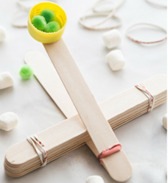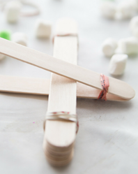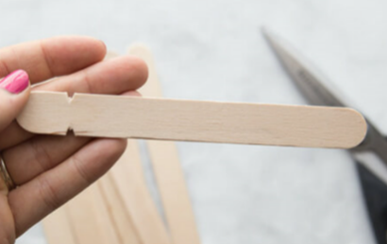Rubber bands
* Bottle cap
* Glue
* Small marshmallows

# **Instructions:**

1. Glue a pop/water cap to one of the notched sticks on the opposite end from the notch and set aside to dry
2. Stack 8, uncut, popsicle sticks and rubber band them tightly together on each end
3. Push the second notched stick between the 1st and 2nd sticks in the stack
4. Flip the partially made catapult over
5. Lay the stick with the pop/water cap on top of the stack of popsicle sticks to align with the notches in the other stick (making sure the pop/water cap is on top
6. Use a rubber band through the notches to connect the 2 notched sticks
7. Use the marshmallows as projectiles to see how far each can fire their catapult

# **Possible Variations:**

* Move the pivot point to see how it effects the height/distance of projectile
* Compete to see who can get their marshmallows to fly the farthest/highest

# **Science Behind the Project:**

When you pull down the lever arm all the potential energy gets stored. Release it and that potential energy transfers to kinetic energy sending the marshmallow flying! Gravity and drag do their part to slow the marshmallow down and pull it back down to the grounds.