

**Paper Plate Marble Maze**

**3-5**

**Activity #2**

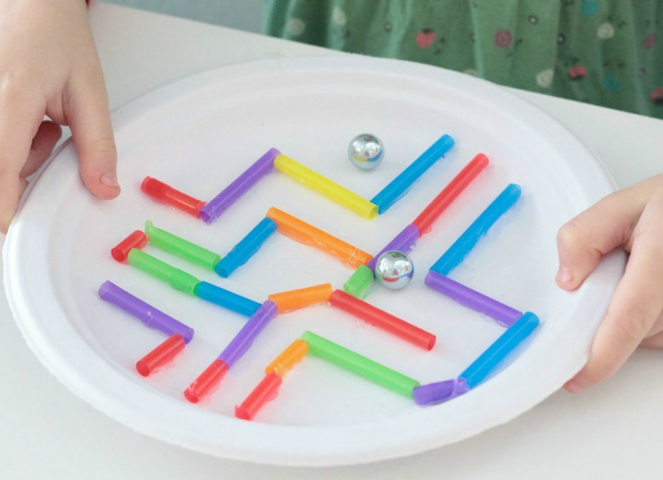**Estimated Time**:

1 hour

# **Materials (per student):**

* Paper Plate
* Marble
* Straws
* Paper
* Scissors (not included)
* Glue/Tape (not included)

# **Instructions:**

* The goal of this project is to get a maze made that fits a marble that is contained inside a paper plate. The maze must work completely, and it shouldn’t break when playing with it.
* Construct a maze using plastic straws. Please see the criteria you must meet. Your maze should include:
  + 5 turns
  + 2 tunnels

# **Possible Variations:**

* Use other household items that include, but not limited to:
  + Cardboard
  + Cotton Balls
  + String
* Be **creative** in your maze design with the extra household materials.

# **Science Behind the Project:**

This project allows students to think for themselves in the creation of their maze. They must follow all elements of a real design process including brainstorming, blueprints, prototypes, tweaking, and testing their design.

**\*\*WARNING: Adult Supervision Required. Small parts may cause a choking hazard\*\***