

**Building Straw Rockets**

**K-2**

# Related image**Estimated Time:**

20-30 minutes

# **Materials:**

* Paper
* Straws
* Tape

# **Instructions:**

1. Start with a 3 X 5-inch piece of paper. You may want to adjust this later depending on the size of your straw. Roll your paper into a tube large enough that it will easily fit over your straw.
2. Bend about 1/2 inch of one end of your paper tube to close that end and secure it with a small piece of tape.
3. Place the paper tube on the straw. Hold the straw to your mouth and blow. Your straw rocket should launch!

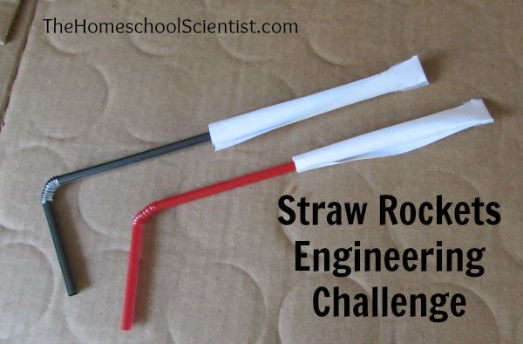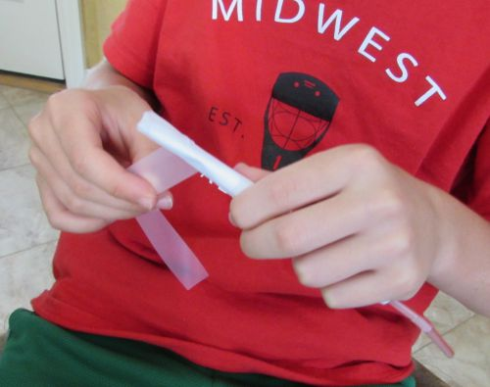

# **Experimenting with Your Straw Rocket**

* Try changing the amount and force of air you blow through the straw. What difference does that make?
* What happens when you vary the length of the paper tube?
* What happens when you vary the diameter of the paper tube?
* Change the shape of your straw rocket by adding wings or a nose cone. What effects do those changes have on the flight of your rocket?
* Try different weights of paper for your rocket? What happens?

