

**Skittles Experiment**

**Activity #1**

**6-8**

# **Construction Materials:**

* Skittles
* Water
* Paper Plate

# **Instructions:**

1. Empty out your Skittles and check out the colors.
2. Lay out your plate in an area where they won’t be disturbed
3. Place the Skittles on your plate in any pattern or design you would like.
4. Once you have your patterned placed, gently begin pouring water in the middle of the plate until it reaches all the Skittles. You will want the water to just barely cover them.

# **Possible Variations:**

* Test out the Skittle experiment with different liquids.
* Test out warm water vs. cold water.

# **The Science:**

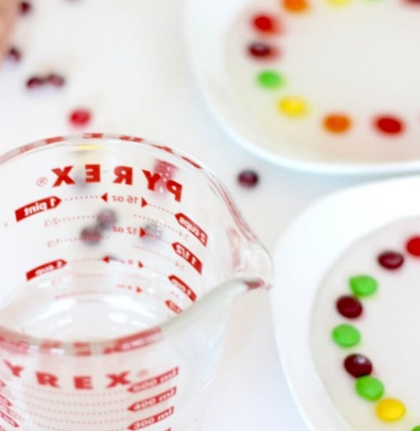Skittles are made of ingredients that dissolve in water. They also do it quickly, so you have neat science right away. Dissolving candy is fun to test out with a variety of liquids and candy. Find out how different candy dissolve at different rates.

