

**Balloon-Powered Car Challenge**

**K-2**

# **Estimated Time:**

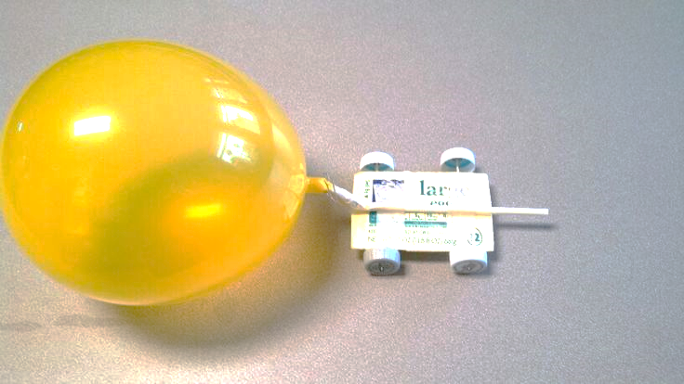20-30 minutes

# **Materials:**

* Cardboard Rectangles
* Bendy Straws
* Scotch Tape
* Balloons – 9”
* Wooden Skewers
* Wheels – (bottle caps, CDs, toy wheels)
* Scissors

# **Instructions:**

1. Attach small straw sections to bottom of cardboard as shown below and insert wooden skewer. Repeat for other side as these will be the cars axles.
2. Attach balloon to bendy side of straw using tape (assistance may be required). Then tape this to the cardboard rectangle as shown below.
3. Attach wheels and have children inflate balloon by blowing through the straw. Hold finger over straw to prevent air from escaping, then set the car down on the “track” and watch it move!

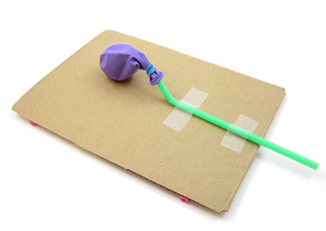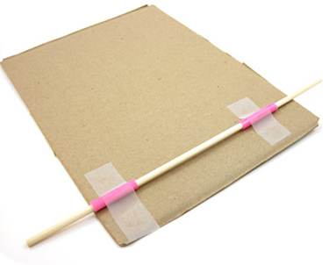

# **The Science:**

Have you ever blown up a balloon and then let it go, without tying it shut? The air rapidly escapes from the balloon, making it zip all over the room! This is because when you blow up a balloon, you increase the air pressure inside the balloon. This air pressure stretches out the rubber balloon material, just like stretching a rubber band.

 

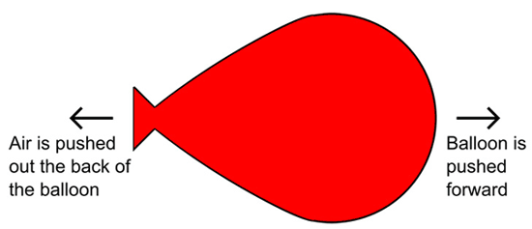

When you just let a balloon go on its own, it tends to randomly fly around the room, and is almost impossible to steer. However, when you attach the balloon to a toy car, you can connect the balloon's energy to push the car forward!