

**Note Card Tower**

**K-2**

**Activity #1**

# **Estimated Time:**

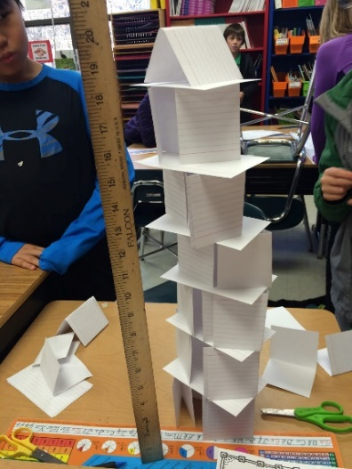45 minutes

# **Materials:**

* 1 package of index cards (50 cards)
* Tape (not included)
* Scissors (not included)

# **Activity:**

Create the tallest index card tower that is free standing and remains self-supporting for 10 seconds.

# **Rules:**

1. Complete the construction of the tower in 30 minutes.
2. The index cards may be cut into pieces and reassembled as desired.
3. Tape is to be used to fasten parts of the tower together, it may not be used to attach the tower to the floor or any object. Tape may not be used to extend the height of the tower.

# **Possible Variations:**

* Compete in teams to determine who can construct the highest free-standing tower.
* Add one penny to the top of the tower. If the tower holds, place another penny on top of the tower. Keep adding pennies to see how many pennies your tower can hold.

**\*\*WARNING: Adult Supervision Required. Small parts may cause a choking hazard\*\***