

**Mini Wave Model**

**9-12**

**Activity #2**

# **Objective**

The purpose is to build your own mini wave model that demonstrates wave motion that occurs in things such as light and sound.

# **Materials**

* 12” boards
* 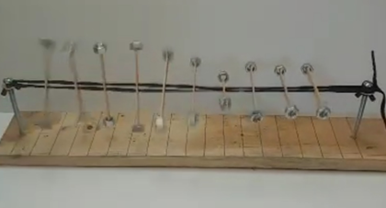Dowels
* Popsicle sticks (with 2 holes in the middle and notches

on ends)

* Nuts
* Screws
* Wing nuts
* Washers
* Shoelace
* Screwdriver ***(not provided)***
* Emler’s glue ***(not provided)***
* Duct tape ***(not provided*)**

# **Instructions**

1. Take the 2 12” boards and locate the ends with 2 holes in them. Next, locate which side of each board the holes are drilled on – arrange the boards so these sides both face up and the ends with the holes are facing each other.
2. Squirt some Elmer’s glue in each of the end holes and insert the dowels into the holes on one board.
3. Line up the second board with the first and push onto dowels. Boards should be nearly flush. While carefully applying pressure to hold the boards as flush as possible, wrap duct tape once around the seam to reinforce the glue/dowels. Set aside to allow glue to dry. NOTE: If duct tape is not available, this step can be completed without it. However, using the duct tape to reinforce the dowels is highly recommended.
4. While glue is drying, carefully thread nuts onto ends of popsicle stick by rotating them clockwise. This may take some patience at first but will get easier after the first few sticks. DO NOT just try to push nuts onto sticks – this could result in a broken stick. 4 additional sticks beyond what is needed are provided in case a fracture does happen.
5. Place a washer and a wing nut on each screw as shown in the photo.
6. 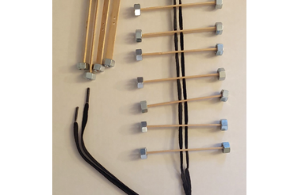Once glue is dry, set board on a flat surface. Carefully thread a screw into each hole at the end of the board. You should be able to start the screw by hand and then use a screwdriver to finish it. Screws should be the same height when you finish.
7. OPTIONAL: Use a ruler to measure one-inch intervals between the screws. Draw lines across the board using pencil/pen/marker or other writing utensil. These lines will make it easier to space your popsicle sticks later on.
8. Take your shoestring and fold it in half. Thread the popsicle sticks onto the shoestring, one end of the string through each hole so it looks like the picture.

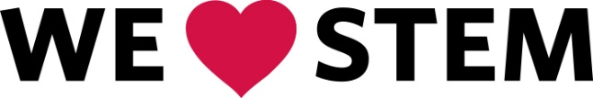



**Mini Wave Model**

**Activity #2**

**9-12**

1. Take the loop end of the shoestring and put it around one of the screws above the washer. While holding the string taut by the ends, tighten the wing nut until the string is held securely in place next to the head of the screw.
2. Take one end of the string and wrap it around the screw once – do the same with the other end.
3. Pull the string as taut as possible and tie a square knot (or a bow) to secure it to the screw. The tauter the string is the better the wave will propagate along your model.

***Caution:*** While your boards should be pretty well held together, pay attention to the seam – if it starts bowing extremely, you are holding it too taut.

1. Like with the loop end of the string, tighten the wing nut until the string/knot is held securely against the head of screw.
2. Adjust the popsicle sticks so that they are equally spaced (if you chose to draw lines on the board, use these to help you but beware of parallax).
3. Tap a popsicle stick of either end of your model - the wave it creates should propagate along your model. The harder you tap the stick, the bigger the wave.

**The Science:**

A wave can be thought of as a disturbance or oscillation that transfers energy from one point to another, typically without permanently displacing the particles of the medium. Light and sound are both “transferred” with wave motion. The height of a wave is called its amplitude, and the distance between peaks is called a wavelength. Waves can add together to create bigger waves (constructive interference) or cancel each other out (destructive interference).

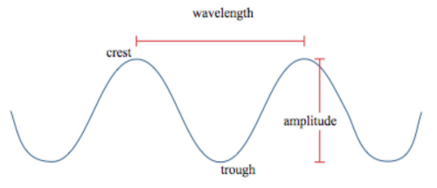

**Questions to Think About**

* What happens when you change the spacing and/or amount of popsicle sticks on the wave model?
* What would happen to the wave amplitude if you took the nuts off of your popsicle sticks?
* What happens if you turn the wave model vertical? Why?
* Can you cause constructive or destructive interference?
* Your wave eventually stops due to energy loss – where might it be losing energy to?

