

**Bottle Silvering**

# **Safety**

**6-8**

* Wear disposable nitrite gloves
* 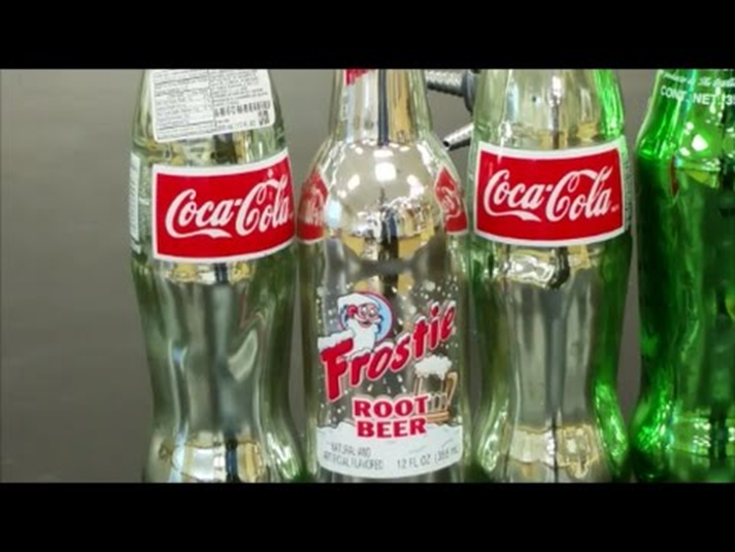Wear safety glasses

# **Materials:**

* Clear glass bottle.
* Rubber stopper
* Beaker
* Measuring cylinders
* Pipette
* Potassium Nitrate
* Glucose/Dextrose
* Ammonia Solutions

# **Procedure:**

1. Place measure amount of silver nitrate into beaker
2. Slowly add ammonia by using a pipette to silver nitrate into beaker. The solution will turn brown first. Continue adding drops of ammonia until the solution re-dissolves to be clear in color.
3. Add in measured amount of potassium hydroxide. The solution will turn back to dark brown in color. This is silver oxide forming.
4. Add in more ammonia like step 2; until the solutions becomes clear again.
5. Pour the beaker solution into the glass bottle
6. Add measured amount of glucose solution and insert rubber stopper.
7. Give the student the bottle to begin swirling solution all around inside. Swirl until a mirror forms (1-2 minutes).
8. Remove rubber stopper and empty excess solution into bucket. (Bucket will be transported and disposed of properly once all students are done)
9. Rinse flask out with water and discard rinse water to bucket.
10. 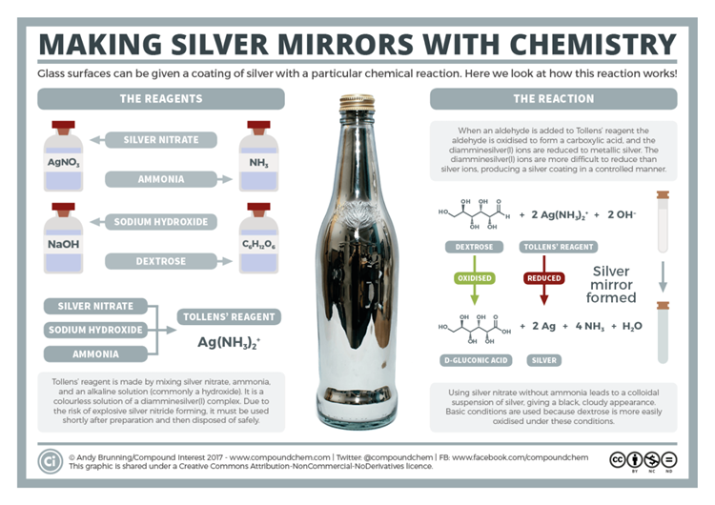Insert the rubber stopper back into bottle

# **Teaching Info:**

Two colorless liquids are poured into a clear glass bottle. The bottle is then stoppered and swirled. In about 2 minutes if swirling, the inside of the glass darkens and obtains a mirror like reflection. When organic sugar is combined with an ammonia complex of silver in a basic aqueous solution, the sugar slowly reduces the complex to silver metal. When the surface of the glass is clean and wet, the silver metal adheres to the glass, forming a highly reflective surface.