

**Mini Egg Drop**

**3-5**

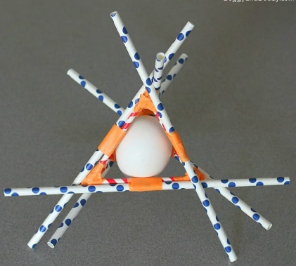**Estimated Time**: 30 minutes

# **Materials (per team):**

* 10 paper straws
* 1 roll of masking/painter’s tape
* 1 egg

# **Instructions:**

1. Split the group into teams of 3-4 (4 total teams for each session)
2. Provide each team with the supplies (Straws, tape and egg)
3. Instruct teams to build a structure to hold/protect the egg using the materials provided. The picture below can be shown as an example.
4. Give each team ~20 minutes to make their structure prior to testing.
5. During the testing phase drop the structures into the provided tub at increasing heights. Start at knee high, then waist high, etc. until the egg either breaks or reaches max height (arm extended overhead).
6. Repeat the drop test for each team.

# **Possible Variations:**

If teams complete their structure and testing early they can make modifications and repeat the drop test if time allows.

# **Science Behind the Project:**

There are many forces acting on the egg (gravity, drag, impact, etc.). The kinetic energy from the fall is transferred to the egg. What can be done to the apparatus to maximize drag to slow down the egg and to reduce impact by “soaking up” some of the energy?