

**Scuba Sarah/Scuba Steve**

**Activity #4**

**K-2**

# 

# **Materials:**

* Drinking straw
* Paper clip
* Empty Plastic Two Liter Bottle ***(not provided)***
* Scissors ***(not provided)***
* Water ***(not provided)***

# **Instructions:**

1. Cut the straw and position it on the paperclip as shown above. Each end should be secured by the ends of the paper clips.
2. Add a couple more paper clips.
3. Place some googly eyes on Scuba Sarah/Scuba Steve.
4. Fill a glass with water and put the diver in. This is to test to make sure s/he floats. S/he should float as shown above. If s/he does not float, your straw may have a hole in it. Try again with a new straw.
5. Fill the two-liter bottle with water. Make sure to fill it to the top, otherwise the experiment will not work. Carefully place the diver into the bottle and screw on the lid.
6. Squeeze the bottle and watch as the diver sinks to the bottom. Stop squeezing and he will float back to the top.

# **Possible Variations:**

Add food coloring to the water for extra fun!

**\*\*WARNING: Adult Supervision Required. Small parts may cause a choking hazard\*\***

**Bonus Mini Activity**

**K-2**

**Activity #4**

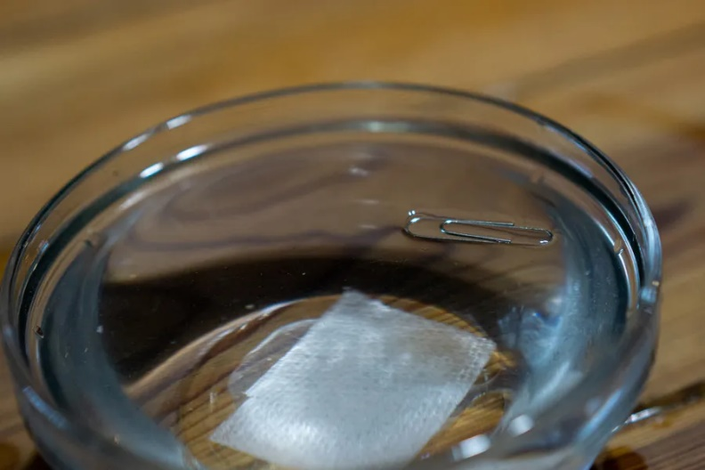

# **Materials:**

* Paper Clip
* Cup of water ***(not provided)***
* Paper towel ***(not provided)***

# **Instructions:**

1. Fill a cup with water.
2. Place a small paper towel square into the water with a paper clip on top.
3. Watch as the paper towel sinks, and the paper clip will float.
4. Touch the water to break the surface tension and watch as the paper clip sinks!

**\*\*WARNING: Adult Supervision Required. Small parts may cause a choking hazard\*\***