

**Straw Rocket**

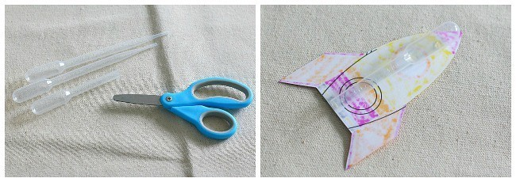

**Activity #3**

**3-5**

# 

# 

# **Materials (per student):**

* Straw
* Plastic Pipette
* Tape (not included)
* Rocket Template

# **Instructions:**

1. Color the rockets and cut them out from the Rocket Printout Sheet supplied.
2. Cut the bottom off a plastic pipette and attach it to the back of a rocket using tape.
3. Slip the straw into your pipette, and you’re ready to launch!
4. Give the straw a big puff of air, and watch it take off!

# **Possible Variations:**

* How does the angle you launch your rocket affect the distance it travels? Try out different angles and record the results.
* Can you design your own rocket to attach to the pipette or straw? Which design works better?
* Try adding another fin to your rocket with tape. How does it affect the flight of your rocket?

**\*\*WARNING: Adult Supervision Required. Small parts may cause a choking hazard. Take special care with coin batteries\*\***