

**SLIME**

**3-5**

# **Estimated Time:**

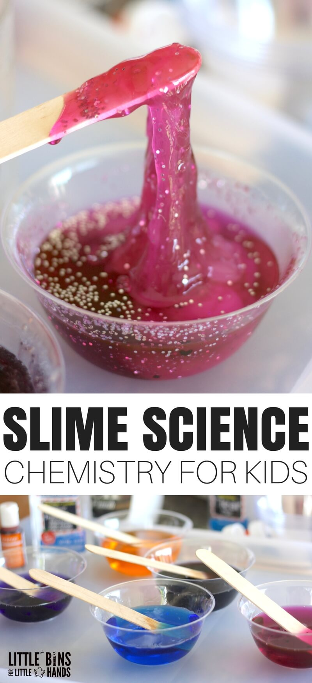20-30 minutes

# **Materials:**

* Glue
* Food coloring, glitter (optional)
* Baking soda
* Contact solution
* Plastic bowls for mixing
* Plastic spoons for mixing
* Ziplock bags for taking home

# **Instructions:**

1. Pour ½ cup Glue into a bowl
2. Add food coloring
3. Add ½ Tbsp Baking Soda
4. Add ¼ Tbsp Contact Solution

** If too sticky add a little bit of contact solution**

1. Knead with hands (apply a small amount of contact solution to hands to prevent sticking)

# **The Science:**

A chemical reaction occurs when the glue is mixed with the borax, which causes a new substance (slime) to form. Slime does not have its own shape. You will notice your slime change its shape to fill whatever container it’s placed in.  However, it can also be bounced like a ball because of its elasticity. Pull the slime slowly and it flows more freely. If you pull it quickly, the slime will break off more easily because you are breaking apart the chemical bonds.