

**Foil Boat**

**Foil Boat**

**Activity #2**

**6-8**

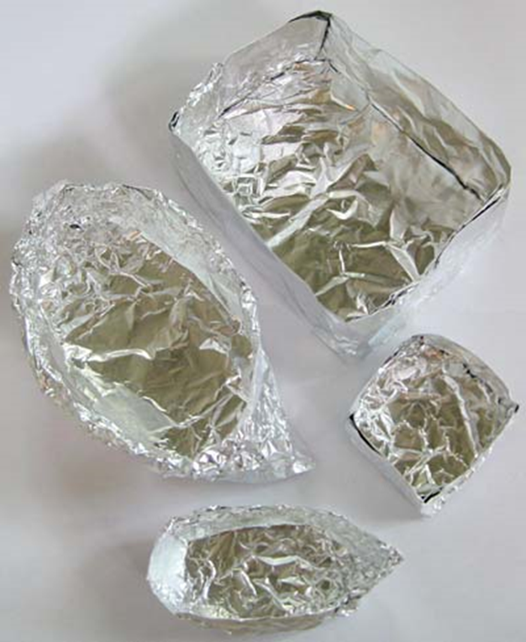

# **Materials:**

* Foil
* Scissors ***(not provided)***
* Tape ***(not provided)***
* Uncooked Rice ***(not provided)***
* Ruler ***(not provided)***
* Container to hold water (bucket, sink, bathtub, etc.) ***(not provided)***
* Pennies ***(not included)***
* Measuring cups ***(not provided)***

# **Instructions:**

1. From a fresh piece of tin foil, cut out two squares. One square should have dimensions that are twice that of the other square. (If you cut one square to be 5” x 5” then the other square should be 10” x 10”).
2. Using the tin foil, create two small boats. If the boats have an enclosed shape and don’t leak, any shape can be used. A simple box will work, but something a little more complicated like a canoe would work just as well! Be sure to make both boats using the same shape.
3. Check to make sure that the boats are not leaking. If they are, they can be strengthened with tape. Make sure the bottom of each boat is flat, and the upper lip of the boat is roughly the same height all the way around the edge.
4. Determine the volume of each boat in the cubic centimeters (cm3). If the shape of the boat is simple, for example a rectangular prism, then a simple volume formula can be used.
   * *The volume for a rectangular prism is given as V = Length x Width x Height*
5. If a boat is not an easily identifiable volume, then another method can be used. Carefully fill the boat with rice without damaging it. Once the rice is filled to the top, transfer the rice into a measuring cup to determine the volume of the rice which will be equivalent to the volume of the boat.
   * *What is the volume of each boat?*
6. Once the volume has been determined, fill the chosen water container (bucket, bathtub, sink, etc.) with water.
7. Float the tin foil on the water, making sure to check for leaks.
8. Now, take the pennies and slowly add them to the boat. Be sure to distribute the pennies evenly, so that all the weight isn’t on one side of the boat.
9. Continue to add pennies in this way until the boat sinks.
10. Record the number of pennies that sunk the boat, excluding the final penny that caused it to sink.





**Foil Boat**

**6-8**

**Activity #2**

1. Repeat this process for the second boat. Be sure to only use dry pennies. If the number of pennies available is limited, dry the pennies that have been submerged with a towel.
   * *Why is it that we pennies shouldn’t be used?*
2. Which boat could hold more pennies before sinking? The larger one or the smaller one?
3. Determine the mass of the total number of pennies that was used in each boat. If a scale is not available, the mass of a single penny is 2.5 grams.
   * *How many grams worth of pennies could each boat support?*
4. To determine the density of each boat, divide the mass in grams that that boat could support by the volume of the boat. Make sure the volume used is in cm3.
   * *Density is given as Density = Mass/Volume*

# **The Science:**

When the boats were first put into the water without any pennies inside of them, they should have floated. This is due to the fact that the density of the boat without any pennies inside is less than that of the water. If an object sinks in a fluid, it is denser than the fluid. If an object floats in fluid, then the object is less dense than the fluid. Therefore, once enough pennies have been added to the boat, it eventually sinks due to the increased mass of adding pennies. The volume is not changing, so the object gets denser. Once enough pennies have been added eventually the density of the boat becomes larger than the water, and the boat sinks. Just prior to adding the last penny to the boat, the density of the boat is going to be roughly equal to the density of the water. The densities at which the two boats sank should have been similar, but the number of pennies should have been different. Knowing both the mass and the volume effect the density, why is this? If the volume is larger, the mass (the number of pennies put into the boat) will also have to increase to match the density of the water.

