

**Balloon Powered Car**

# **Time:**

**6-8**

* 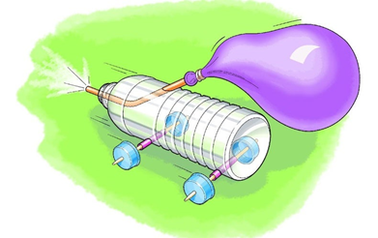15-20 minutes of build time
* 10-minute race time

# **Materials**

* Body
  + Cardboard
  + Plastic Bottle
  + Tissue Box
* Wheels
  + CDs
  + Bottle Caps
  + 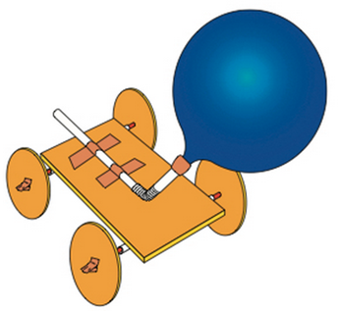Washers
* Axels
  + Straws
  + Wooden Skewers
* Engine
  + Balloon
  + Bendy Straws
* Additional Items
  + Rubber Bands
  + Tape
  + Scissors
  + Glue
  + Sticky Puddy

# **Instructions**

You are free to create the car however you want. The pictures above are just ideas to help guide you

1. Choose your style of body (x1)
2. Choose your wheels (x4)
   1. CDs, Bottle Caps, Washers (Can mix and match)
3. Grab regular (x2) and bendy (x2) straws, wooden skewers (x2), balloon (x1), and any additional items you may need.
4. Fasten regular straw to your car
   1. This will be your axel
5. Attach wheels (of choice) to axels
6. Attach bendy straw to balloon and then to car
7. Ask if assistance is needed.

# **The Objective:**

* Race Head-to-head against other groups tournament style
* Advance by having your car cross the finish line first
  + If no one crosses the line, then the closest car to the finish line wins.

# **The Science:**

* By blowing air into the balloon, you are creating a pocket of high pressure
* The high pressure wants to equal out the lower, outside, pressure
  + 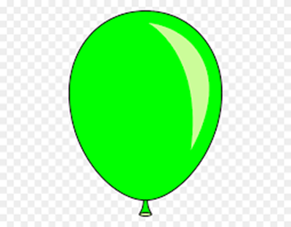The two pressures want to be at equilibrium

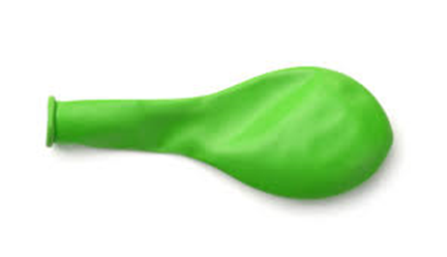









* When the air escapes it will enact a force upon the car
  + Every force has an opposite but equal reaction force (Newton’s 3rd Law)
* This opposite force causes your car to move forward