

**Rain Cloud in a Jar**

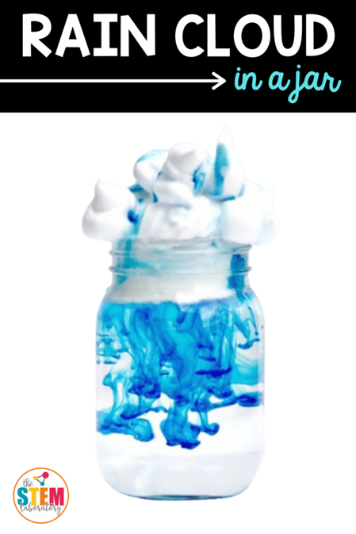

**K-2**

# **Materials:**

* Food Coloring
* Water
* A Clear Jar
* Shaving Cream
* Plastic Pipettes

# **Instructions:**

1. Mix a few drops of food coloring into water.
2. Fill glass about ¾ full of cool water.
3. Use the shaving cream on the top to make a “cloud”
4. Suck some of the colored water into the pipette and squirt it on top of the shaving cream cloud.
5. Add more colored water until the first drops of colored rain make their wat through the cloud and begin to drop.

# **The Science:**

Clouds are formed when water vapor rises into the air and condenses onto tiny particles of dust. When billions of these droplets come together, a visible cloud forms. Over time, the droplets and crystals that make up a cloud can attract more water to themselves. When water droplets grow heavy enough, gravity pulls them down as raindrops.