

**Robot Hand**

**3-5**

**Activity #2**

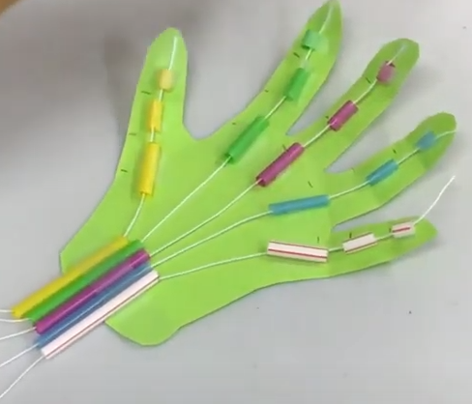

# **Materials (per student):**

* Cardboard
* String
* Straw
* Tape or glue ***(not included)***
* Pencil ***(not included)***

# **Instructions:**

1. Trace your hand onto cardboard and cut it out.
2. Cut straws into pieces (see reference picture).
3. Using tape or glue, attach the straw pieces to the hand.
4. Crease the cardboard in between the straws – these will stimulate your joints.
5. Thread each piece of yarn through the straw pieces, starting with the fingertips and ending at the palm of your hand. Each finger should be controlled by one string. Tape string to end of each finger.
6. Use the strings together or independently to control the movement of each of the fingers. Congrats on your new robot hand!

**\*\*WARNING: Adult Supervision Required. Small parts may cause a choking hazard\*\***